**Digital nurture Deep skilling-Week3**

**Spring Core Maven**

**Exercise 1: Configuring a Basic Spring Application**

**Scenario:**

Your company is developing a web application for managing a library. You need to use the Spring Framework to handle the backend operations.

**Steps:**

1. **Set Up a Spring Project:**
   * Create a Maven project named **LibraryManagement**.
   * Add Spring Core dependencies in the **pom.xml** file.
2. **Configure the Application Context:**
   * Create an XML configuration file named **applicationContext.xml** in the **src/main/resources** directory.
   * Define beans for **BookService** and **BookRepository** in the XML file.
3. **Define Service and Repository Classes:**
   * Create a package **com.library.service** and add a class **BookService**.
   * Create a package **com.library.repository** and add a class **BookRepository**.
4. **Run the Application:**
   * Create a main class to load the Spring context and test the configuration.

**Code:**

**Pom.xml**

<?xml version="1.0" encoding="UTF-8"?>

<project xmlns="http://maven.apache.org/POM/4.0.0" xmlns:xsi="http://www.w3.org/2001/XMLSchema-instance"

xsi:schemaLocation="http://maven.apache.org/POM/4.0.0 http://maven.apache.org/xsd/maven-4.0.0.xsd">

<modelVersion>4.0.0</modelVersion>

<groupId>com.library</groupId>

<artifactId>LibraryManagement</artifactId>

<version>0.0.1-SNAPSHOT</version>

<name>LibraryManagement</name>

<!-- FIXME change it to the project's website -->

<url>http://www.example.com</url>

<properties>

<project.build.sourceEncoding>UTF-8</project.build.sourceEncoding>

<maven.compiler.release>17</maven.compiler.release>

</properties>

<dependencyManagement>

<dependencies>

<dependency>

<groupId>org.junit</groupId>

<artifactId>junit-bom</artifactId>

<version>5.11.0</version>

<type>pom</type>

<scope>import</scope>

</dependency>

</dependencies>

</dependencyManagement>

<dependencies>

<dependency>

<groupId>org.junit.jupiter</groupId>

<artifactId>junit-jupiter-api</artifactId>

<scope>test</scope>

</dependency>

<!-- Optionally: parameterized tests support -->

<dependency>

<groupId>org.junit.jupiter</groupId>

<artifactId>junit-jupiter-params</artifactId>

<scope>test</scope>

</dependency>

<dependency>

<groupId>org.springframework</groupId>

<artifactId>spring-context</artifactId>

<version>5.3.33</version>

</dependency>

</dependencies>

<build>

<pluginManagement><!-- lock down plugins versions to avoid using Maven defaults (may be moved to parent pom) -->

<plugins>

<!-- clean lifecycle, see https://maven.apache.org/ref/current/maven-core/lifecycles.html#clean_Lifecycle -->

<plugin>

<artifactId>maven-clean-plugin</artifactId>

<version>3.4.0</version>

</plugin>

<!-- default lifecycle, jar packaging: see https://maven.apache.org/ref/current/maven-core/default-bindings.html#Plugin_bindings_for_jar_packaging -->

<plugin>

<artifactId>maven-resources-plugin</artifactId>

<version>3.3.1</version>

</plugin>

<plugin>

<artifactId>maven-compiler-plugin</artifactId>

<version>3.13.0</version>

</plugin>

<plugin>

<artifactId>maven-surefire-plugin</artifactId>

<version>3.3.0</version>

</plugin>

<plugin>

<artifactId>maven-jar-plugin</artifactId>

<version>3.4.2</version>

</plugin>

<plugin>

<artifactId>maven-install-plugin</artifactId>

<version>3.1.2</version>

</plugin>

<plugin>

<artifactId>maven-deploy-plugin</artifactId>

<version>3.1.2</version>

</plugin>

<!-- site lifecycle, see https://maven.apache.org/ref/current/maven-core/lifecycles.html#site_Lifecycle -->

<plugin>

<artifactId>maven-site-plugin</artifactId>

<version>3.12.1</version>

</plugin>

<plugin>

<artifactId>maven-project-info-reports-plugin</artifactId>

<version>3.6.1</version>

</plugin>

</plugins>

</pluginManagement>

</build>

</project>

**applicationsContext.xml**

<?xml version="1.0" encoding="UTF-8"?>

<beans xmlns="http://www.springframework.org/schema/beans"

xmlns:xsi="http://www.w3.org/2001/XMLSchema-instance"

xsi:schemaLocation="

http://www.springframework.org/schema/beans

http://www.springframework.org/schema/beans/spring-beans.xsd">

<!-- Define Repository Bean -->

<bean id="bookRepository" class="com.library.repository.BookRepository" />

<!-- Define Service Bean with Dependency Injection -->

<bean id="bookService" class="com.library.service.BookService">

<property name="bookRepository" ref="bookRepository" />

</bean>

</beans>

**MainApp.java**

package com.library;

import org.springframework.context.support.ClassPathXmlApplicationContext;

import com.library.service.BookService;

public class MainApp {

public static void main(String[] args) {

// Try-with-resources block automatically closes context

try (ClassPathXmlApplicationContext context = new ClassPathXmlApplicationContext("applicationContext.xml")) {

BookService bookService = (BookService) context.getBean("bookService");

bookService.listBooks();

}

}

}

**BookService.java**

package com.library.service;

import com.library.repository.BookRepository;

public class BookService {

private BookRepository bookRepository;

// Setter for injection

public void setBookRepository(BookRepository bookRepository) {

this.bookRepository = bookRepository;

}

public void listBooks() {

System.***out***.println("🔎 BookService: Listing all books...");

bookRepository.fetchBooks();

}

}

**BookRepository.java**

package com.library.repository;

public class BookRepository {

public void fetchBooks() {

System.***out***.println("📚 Fetching books from the database...");

}

}

**Output:** 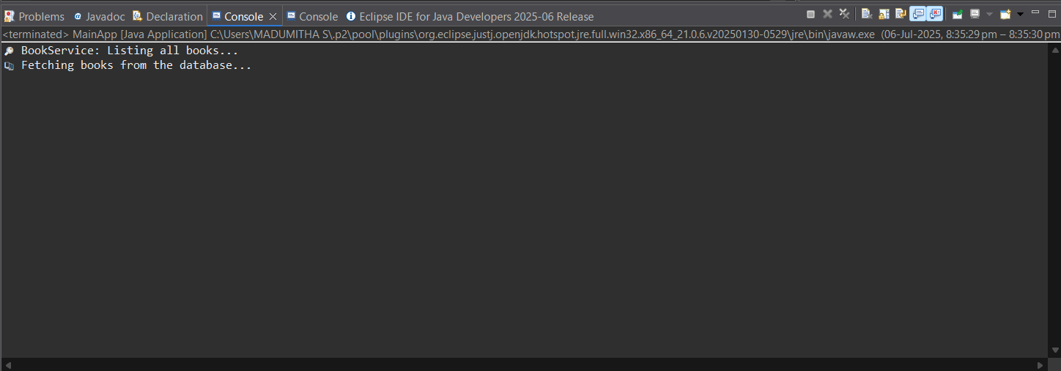

**Exercise 2: Implementing Dependency Injection**

**Scenario:**

In the library management application, you need to manage the dependencies between the BookService and BookRepository classes using Spring's IoC and DI.

**Steps:**

1. **Modify the XML Configuration:**
   * Update **applicationContext.xml** to wire **BookRepository** into **BookService**.
2. **Update the BookService Class:**
   * Ensure that **BookService** class has a setter method for **BookRepository**.
3. **Test the Configuration:**
   * Run the **LibraryManagementApplication** main class to verify the dependency injection.

**Code:  
Pom.xml:**

<?xml version="1.0" encoding="UTF-8"?>

<project xmlns="http://maven.apache.org/POM/4.0.0" xmlns:xsi="http://www.w3.org/2001/XMLSchema-instance"

xsi:schemaLocation="http://maven.apache.org/POM/4.0.0 http://maven.apache.org/xsd/maven-4.0.0.xsd">

<modelVersion>4.0.0</modelVersion>

<groupId>com.library</groupId>

<artifactId>LibraryManagement</artifactId>

<version>0.0.1-SNAPSHOT</version>

<name>LibraryManagement</name>

<!-- FIXME change it to the project's website -->

<url>http://www.example.com</url>

<properties>

<project.build.sourceEncoding>UTF-8</project.build.sourceEncoding>

<maven.compiler.release>17</maven.compiler.release>

</properties>

<dependencyManagement>

<dependencies>

<dependency>

<groupId>org.junit</groupId>

<artifactId>junit-bom</artifactId>

<version>5.11.0</version>

<type>pom</type>

<scope>import</scope>

</dependency>

</dependencies>

</dependencyManagement>

<dependencies>

<dependency>

<groupId>org.junit.jupiter</groupId>

<artifactId>junit-jupiter-api</artifactId>

<scope>test</scope>

</dependency>

<!-- Optionally: parameterized tests support -->

<dependency>

<groupId>org.junit.jupiter</groupId>

<artifactId>junit-jupiter-params</artifactId>

<scope>test</scope>

</dependency>

<dependency>

<groupId>org.springframework</groupId>

<artifactId>spring-context</artifactId>

<version>5.3.33</version>

</dependency>

</dependencies>

<build>

<pluginManagement><!-- lock down plugins versions to avoid using Maven defaults (may be moved to parent pom) -->

<plugins>

<!-- clean lifecycle, see https://maven.apache.org/ref/current/maven-core/lifecycles.html#clean_Lifecycle -->

<plugin>

<artifactId>maven-clean-plugin</artifactId>

<version>3.4.0</version>

</plugin>

<!-- default lifecycle, jar packaging: see https://maven.apache.org/ref/current/maven-core/default-bindings.html#Plugin_bindings_for_jar_packaging -->

<plugin>

<artifactId>maven-resources-plugin</artifactId>

<version>3.3.1</version>

</plugin>

<plugin>

<artifactId>maven-compiler-plugin</artifactId>

<version>3.13.0</version>

</plugin>

<plugin>

<artifactId>maven-surefire-plugin</artifactId>

<version>3.3.0</version>

</plugin>

<plugin>

<artifactId>maven-jar-plugin</artifactId>

<version>3.4.2</version>

</plugin>

<plugin>

<artifactId>maven-install-plugin</artifactId>

<version>3.1.2</version>

</plugin>

<plugin>

<artifactId>maven-deploy-plugin</artifactId>

<version>3.1.2</version>

</plugin>

<!-- site lifecycle, see https://maven.apache.org/ref/current/maven-core/lifecycles.html#site_Lifecycle -->

<plugin>

<artifactId>maven-site-plugin</artifactId>

<version>3.12.1</version>

</plugin>

<plugin>

<artifactId>maven-project-info-reports-plugin</artifactId>

<version>3.6.1</version>

</plugin>

</plugins>

</pluginManagement>

</build>

</project>

**applicationsContext.xml:**

<?xml version="1.0" encoding="UTF-8"?>

<beans xmlns="http://www.springframework.org/schema/beans"

xmlns:xsi="http://www.w3.org/2001/XMLSchema-instance"

xsi:schemaLocation="

http://www.springframework.org/schema/beans

http://www.springframework.org/schema/beans/spring-beans.xsd">

<!-- Repository Bean -->

<bean id="bookRepository" class="com.library.repository.BookRepository" />

<!-- Service Bean with Repository Injection via Setter -->

<bean id="bookService" class="com.library.service.BookService">

<property name="bookRepository" ref="bookRepository" />

</bean>

</beans>

**MainApp.java**

package com.library;

import org.springframework.context.support.ClassPathXmlApplicationContext;

import com.library.service.BookService;

public class MainApp {

public static void main(String[] args) {

try (ClassPathXmlApplicationContext context = new ClassPathXmlApplicationContext("applicationContext.xml")) {

BookService bookService = (BookService) context.getBean("bookService");

bookService.listBooks(); // This uses injected BookRepository

}

}

}

**BookService.java**

import com.library.repository.BookRepository;

public class BookService {

private BookRepository bookRepository;

// Setter method for Spring to inject

public void setBookRepository(BookRepository bookRepository) {

this.bookRepository = bookRepository;

}

public void listBooks() {

System.***out***.println("🔎 BookService: Listing all books...");

bookRepository.fetchBooks();

}

}

**BookRepository.java**

package com.library.repository;

public class BookRepository {

public void fetchBooks() {

System.***out***.println("📚 Fetching books from the database...");

}

}

**Output:  
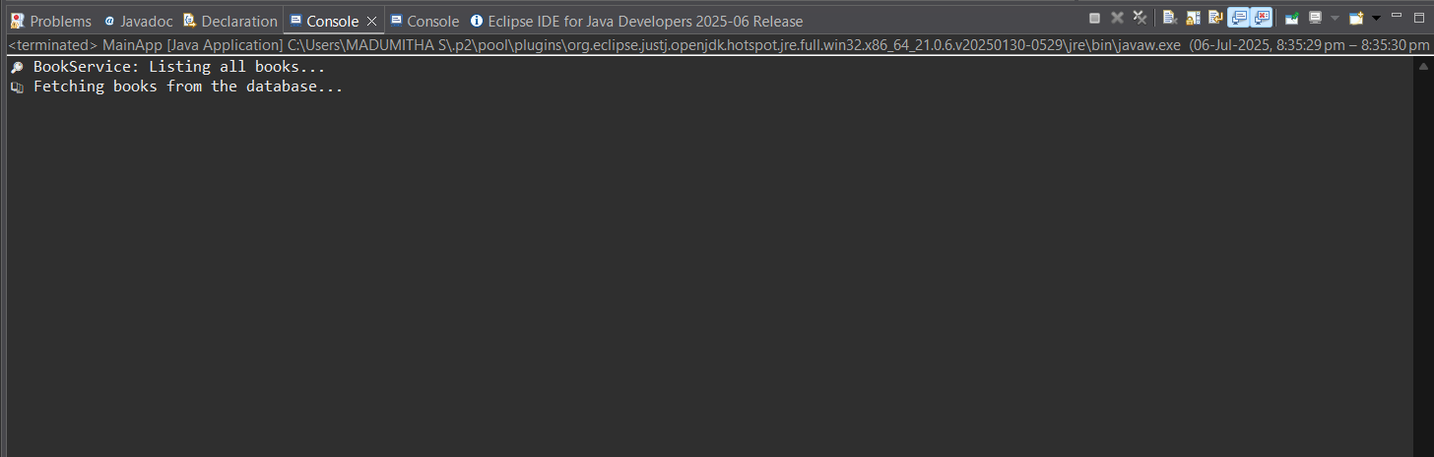**

**Exercise 4: Creating and Configuring a Maven Project**

**Scenario:**

You need to set up a new Maven project for the library management application and add Spring dependencies.

**Steps:**

1. **Create a New Maven Project:**
   * Create a new Maven project named **LibraryManagement**.
2. **Add Spring Dependencies in pom.xml:**
   * Include dependencies for Spring Context, Spring AOP, and Spring WebMVC.
3. **Configure Maven Plugins:**
   * Configure the Maven Compiler Plugin for Java version 1.8 in the pom.xml file.

**Code:**

**Pom.xml:**

<project xmlns="http://maven.apache.org/POM/4.0.0"

xmlns:xsi="http://www.w3.org/2001/XMLSchema-instance"

xsi:schemaLocation="http://maven.apache.org/POM/4.0.0

http://maven.apache.org/xsd/maven-4.0.0.xsd">

<modelVersion>4.0.0</modelVersion>

<groupId>com.library</groupId>

<artifactId>LibraryManagement</artifactId>

<version>1.0-SNAPSHOT</version>

<properties>

<maven.compiler.source>1.8</maven.compiler.source>

<maven.compiler.target>1.8</maven.compiler.target>

</properties>

<dependencies>

<!-- Spring Context -->

<dependency>

<groupId>org.springframework</groupId>

<artifactId>spring-context</artifactId>

<version>5.3.31</version>

</dependency>

<!-- Spring AOP -->

<dependency>

<groupId>org.springframework</groupId>

<artifactId>spring-aop</artifactId>

<version>5.3.31</version>

</dependency>

<!-- Spring Web MVC -->

<dependency>

<groupId>org.springframework</groupId>

<artifactId>spring-webmvc</artifactId>

<version>5.3.31</version>

</dependency>

<!-- Servlet API (required for Spring MVC only at compile time) -->

<dependency>

<groupId>javax.servlet</groupId>

<artifactId>javax.servlet-api</artifactId>

<version>4.0.1</version>

<scope>provided</scope>

</dependency>

</dependencies>

<build>

<plugins>

<!-- Compiler Plugin for Java 8 -->

<plugin>

<groupId>org.apache.maven.plugins</groupId>

<artifactId>maven-compiler-plugin</artifactId>

<version>3.8.1</version>

<configuration>

<source>1.8</source>

<target>1.8</target>

</configuration>

</plugin>

</plugins>

</build>

</project>

**applicationsContext.xml:**

<?xml version="1.0" encoding="UTF-8"?>

<beans xmlns="http://www.springframework.org/schema/beans"

xmlns:xsi="http://www.w3.org/2001/XMLSchema-instance"

xsi:schemaLocation="

http://www.springframework.org/schema/beans

https://www.springframework.org/schema/beans/spring-beans.xsd">

<bean id="bookRepository" class="com.library.BookRepository" />

<bean id="bookService" class="com.library.BookService">

<property name="bookRepository" ref="bookRepository" />

</bean>

</beans>

**BookRepository.java**

package com.library;

public class BookRepository {

public String getBookTitle() {

return "The Pragmatic Programmer";

}

}

**BookService.java**

package com.library;

public class BookService {

private BookRepository bookRepository;

public void setBookRepository(BookRepository bookRepository) {

this.bookRepository = bookRepository;

}

public void displayBook() {

System.***out***.println("Book: " + bookRepository.getBookTitle());

}

}

**MainApp.java:**

package com.library;

import org.springframework.context.support.ClassPathXmlApplicationContext;

public class MainApp {

public static void main(String[] args) {

try (ClassPathXmlApplicationContext context = new ClassPathXmlApplicationContext("applicationContext.xml")) {

BookService bookService = (BookService) context.getBean("bookService");

bookService.displayBook();

}

}

}

**Output:  
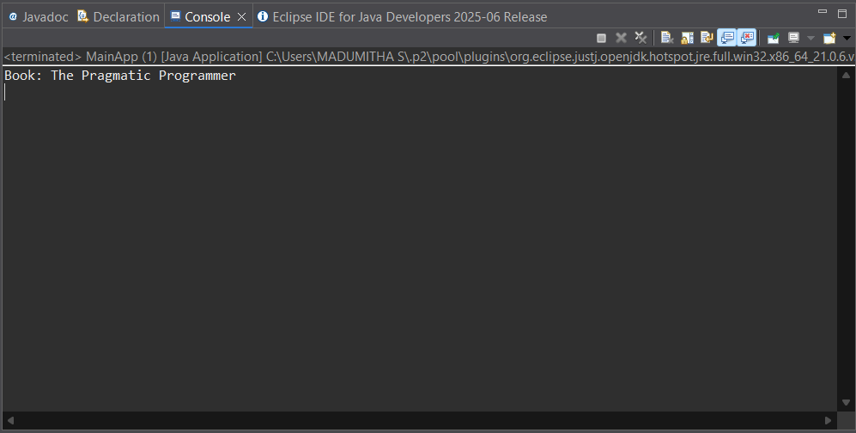**

**Spring Data JPA with Hibernate**

**Hands on 1-Spring Data JPA - Quick Example**

*Software Pre-requisites*

* *MySQL Server 8.0*
* *MySQL Workbench 8*
* *Eclipse IDE for Enterprise Java Developers 2019-03 R*
* *Maven 3.6.2*

*Create a Eclipse Project using Spring Initializr*

* *Go to*[*https://start.spring.io/*](https://start.spring.io/)
* *Change Group as “com.cognizant”*
* *Change Artifact Id as “orm-learn”*
* *In Options > Description enter "Demo project for Spring Data JPA and Hibernate"*
* *Click on menu and select "Spring Boot DevTools", "Spring Data JPA" and "MySQL Driver"*
* *Click Generate and download the project as zip*
* *Extract the zip in root folder to Eclipse Workspace*
* *Import the project in Eclipse "File > Import > Maven > Existing Maven Projects > Click Browse and select extracted folder > Finish"*
* *Create a new schema "ormlearn" in MySQL database. Execute the following commands to open MySQL client and create schema.*

*> mysql -u root -p*

*mysql> create schema ormlearn;*

* *In orm-learn Eclipse project, open src/main/resources/application.properties and include the below database and log configuration.*

*# Spring Framework and application log*

*logging.level.org.springframework=info*

*logging.level.com.cognizant=debug*

*# Hibernate logs for displaying executed SQL, input and output*

*logging.level.org.hibernate.SQL=trace*

*logging.level.org.hibernate.type.descriptor.sql=trace*

*# Log pattern*

*logging.pattern.console=%d{dd-MM-yy} %d{HH:mm:ss.SSS} %-20.20thread %5p %-25.25logger{25} %25M %4L %m%n*

*# Database configuration*

*spring.datasource.driver-class-name=com.mysql.cj.jdbc.Driver*

*spring.datasource.url=jdbc:mysql://localhost:3306/ormlearn*

*spring.datasource.username=root*

*spring.datasource.password=root*

*# Hibernate configuration*

*spring.jpa.hibernate.ddl-auto=validate*

*spring.jpa.properties.hibernate.dialect=org.hibernate.dialect.MySQL5Dialect*

* *Build the project using ‘mvn clean package -Dhttp.proxyHost=proxy.cognizant.com -Dhttp.proxyPort=6050 -Dhttps.proxyHost=proxy.cognizant.com -Dhttps.proxyPort=6050 -Dhttp.proxyUser=123456’ command in command line*
* *Include logs for verifying if main() method is called.*

*import org.slf4j.Logger;*

*import org.slf4j.LoggerFactory;*

*private static final Logger LOGGER = LoggerFactory.getLogger(OrmLearnApplication.class);*

*public static void main(String[] args) {*

*SpringApplication.run(OrmLearnApplication.class, args);*

*LOGGER.info("Inside main");*

*}*

* *Execute the OrmLearnApplication and check in log if main method is called.*

*SME to walk through the following aspects related to the project created:*

1. *src/main/java - Folder with application code*
2. *src/main/resources - Folder for application configuration*
3. *src/test/java - Folder with code for testing the application*
4. *OrmLearnApplication.java - Walkthrough the main() method.*
5. *Purpose of @SpringBootApplication annotation*
6. *pom.xml*
   1. *Walkthrough all the configuration defined in XML file*
   2. *Open 'Dependency Hierarchy' and show the dependency tree.*

*Country table creation*

* *Create a new table country with columns for code and name. For sample, let us insert one country with values 'IN' and 'India' in this table.*

*create table country(co_code varchar(2) primary key, co_name varchar(50));*

* *Insert couple of records into the table*

*insert into country values ('IN', 'India');*

*insert into country values ('US', 'United States of America');*

*Persistence Class - com.cognizant.orm-learn.model.Country*

* *Open Eclipse with orm-learn project*
* *Create new package com.cognizant.orm-learn.model*
* *Create Country.java, then generate getters, setters and toString() methods.*
* *Include @Entity and @Table at class level*
* *Include @Column annotations in each getter method specifying the column name.*

*import javax.persistence.Column;*

*import javax.persistence.Entity;*

*import javax.persistence.Id;*

*import javax.persistence.Table;*

*@Entity*

*@Table(name="country")*

*public class Country {*

*@Id*

*@Column(name="code")*

*private String code;*

*@Column(name="name")*

*private String name;*

*// getters and setters*

*// toString()*

*}*

*Notes:*

* *@Entity is an indicator to Spring Data JPA that it is an entity class for the application*
* *@Table helps in defining the mapping database table*
* *@Id helps is defining the primary key*
* *@Column helps in defining the mapping table column*

*Repository Class - com.cognizant.orm-learn.CountryRepository*

* *Create new package com.cognizant.orm-learn.repository*
* *Create new interface named CountryRepository that extends JpaRepository<Country, String>*
* *Define @Repository annotation at class level*

*import org.springframework.data.jpa.repository.JpaRepository;*

*import org.springframework.stereotype.Repository;*

*import com.cognizant.ormlearn.model.Country;*

*@Repository*

*public interface CountryRepository extends JpaRepository<Country, String> {*

*}*

*Service Class - com.cognizant.orm-learn.service.CountryService*

* *Create new package com.cognizant.orm-learn.service*
* *Create new class CountryService*
* *Include @Service annotation at class level*
* *Autowire CountryRepository in CountryService*
* *Include new method getAllCountries() method that returns a list of countries.*
* *Include @Transactional annotation for this method*
* *In getAllCountries() method invoke countryRepository.findAll() method and return the result*

*Testing in OrmLearnApplication.java*

* *Include a static reference to CountryService in OrmLearnApplication class*

*private static CountryService countryService;*

* *Define a test method to get all countries from service.*

*private static void testGetAllCountries() {*

*LOGGER.info("Start");*

*List<Country> countries = countryService.getAllCountries();*

*LOGGER.debug("countries={}", countries);*

*LOGGER.info("End");*

*}*

* *Modify SpringApplication.run() invocation to set the application context and the CountryService reference from the application context.*

*ApplicationContext context = SpringApplication.run(OrmLearnApplication.class, args);*

*countryService = context.getBean(CountryService.class);*

*testGetAllCountries();*

* *Execute main method to check if data from ormlearn database is retrieved.*

**Code:  
Country.java**

package com.cognizant.ormlearn.model;

import javax.persistence.*;

*@*Entity

*@*Table(name = "country")

public class Country {

*@*Id

*@*Column(name = "co_code")

private String code;

*@*Column(name = "co_name")

private String name;

public String getCode() { return code; }

public void setCode(String code) { this.code = code; }

public String getName() { return name; }

public void setName(String name) { this.name = name; }

*@*Override

public String toString() {

return "Country [code=" + code + ", name=" + name + "]";

}

}

**CountryRepository.java**

package com.cognizant.ormlearn.repository;

import org.springframework.data.jpa.repository.JpaRepository;

import org.springframework.stereotype.Repository;

import com.cognizant.ormlearn.model.Country;

*@*Repository

public interface CountryRepository extends JpaRepository<Country, String> {}

**CountryService.java**

package com.cognizant.ormlearn.service;

import java.util.List;

import javax.transaction.Transactional;

import org.springframework.beans.factory.annotation.Autowired;

import org.springframework.stereotype.Service;

import com.cognizant.ormlearn.model.Country;

import com.cognizant.ormlearn.repository.CountryRepository;

*@Service*

public class CountryService {

*@Autowired*

private CountryRepository countryRepository;

*@*Transactional

public List<Country> getAllCountries() {

return countryRepository.findAll();

}

}

**OrmLearnApplication.java**

package com.cognizant.ormlearn;

import java.util.List;

import com.cognizant.ormlearn.model.Country;

import com.cognizant.ormlearn.service.CountryService;

import org.slf4j.Logger;

import org.slf4j.LoggerFactory;

import org.springframework.boot.SpringApplication;

import org.springframework.boot.autoconfigure.SpringBootApplication;

import org.springframework.context.ApplicationContext;

*@*SpringBootApplication

public class OrmLearnApplication {

private static final Logger ***LOGGER*** = LoggerFactory.getLogger(OrmLearnApplication.class);

private static CountryService *countryService*;

public static void main(String[] args) {

ApplicationContext context = SpringApplication.run(OrmLearnApplication.class, args);

***LOGGER***.info("Inside main");

*countryService* = context.getBean(CountryService.class);

*testGetAllCountries*();

}

private static void testGetAllCountries() {

LOGGER.info("Start");

List<Country> countries = countryService.getAllCountries();

LOGGER.debug("countries={}", countries);

LOGGER.info("End");

}}

**Output:**

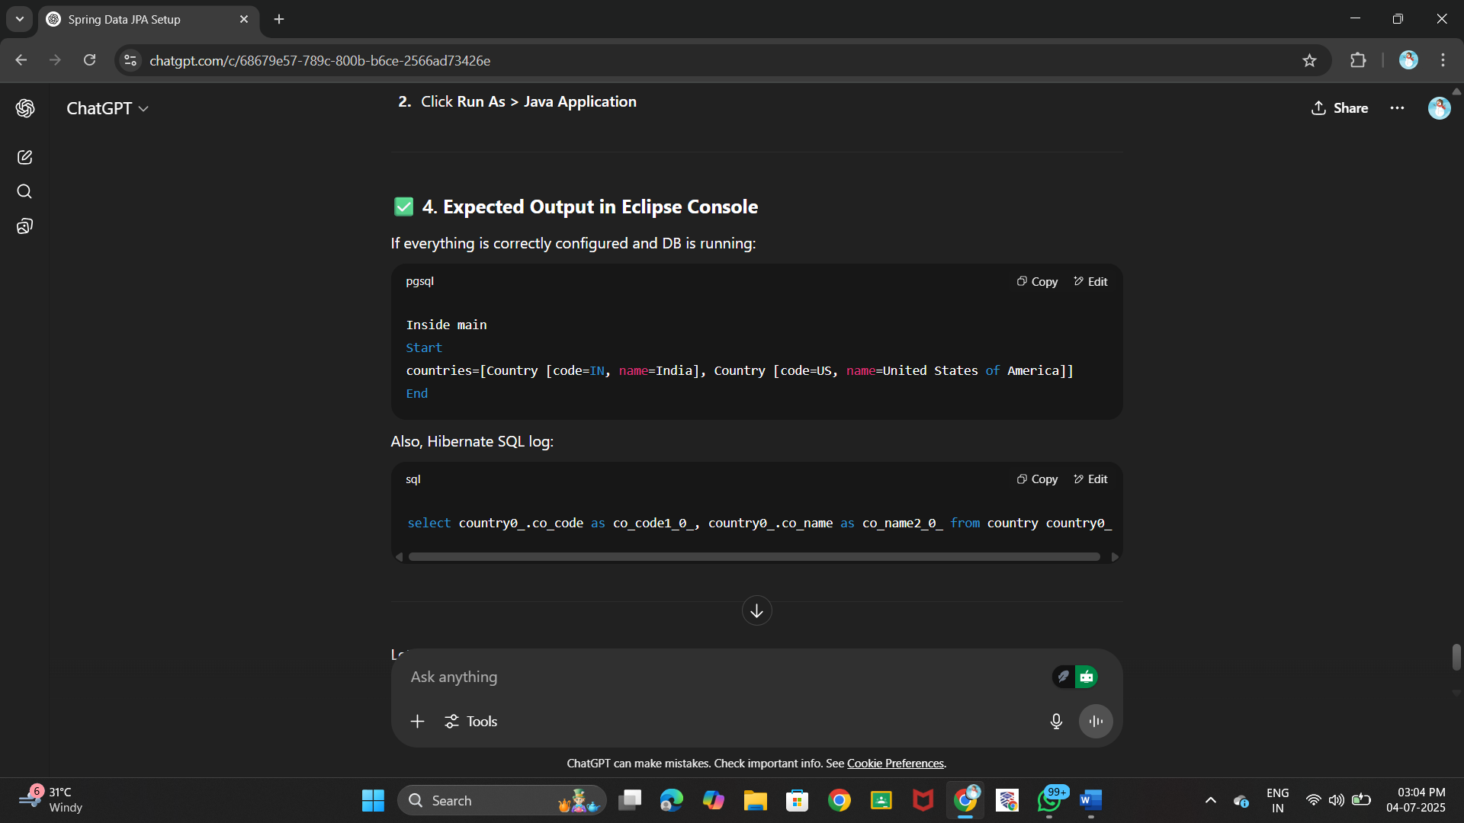



**Hands on 4**

**Difference between JPA, Hibernate and Spring Data JPA**Java Persistence API (JPA)

* JSR 338 Specification for persisting, reading and managing data from Java objects
* Does not contain concrete implementation of the specification
* Hibernate is one of the implementation of JPA

Hibernate

* ORM Tool that implements JPA

Spring Data JPA

* Does not have JPA implementation, but reduces boiler plate code
* This is another level of abstraction over JPA implementation provider like Hibernate
* Manages transactions

Refer code snippets below on how the code compares between Hibernate and Spring Data JPA  
Hibernate

   /* Method to CREATE an employee in the database */

   public Integer addEmployee(Employee employee){

      Session session = factory.openSession();

      Transaction tx = null;

      Integer employeeID = null;

      try {

         tx = session.beginTransaction();

         employeeID = (Integer) session.save(employee);

         tx.commit();

      } catch (HibernateException e) {

         if (tx != null) tx.rollback();

         e.printStackTrace();

      } finally {

         session.close();

      }

      return employeeID;

   }

Spring Data JPA  
EmployeeRespository.java

public interface EmployeeRepository extends JpaRepository<Employee, Integer> {

}

EmployeeService.java

@Autowire

  private EmployeeRepository employeeRepository;

@Transactional

public void addEmployee(Employee employee) {

  employeeRepository.save(employee);

  }

**Code:**

**Employee.java**

package com.example.springdemo.model;

import javax.persistence.*;

*@*Entity

*@*Table(name = "employee")

public class Employee {

*@*Id

private int id;

private String name;

private double salary;

public int getId() { return id; }

public void setId(int id) { this.id = id; }

public String getName() { return name; }

public void setName(String name) { this.name = name; }

public double getSalary() { return salary; }

public void setSalary(double salary) { this.salary = salary; }

*@*Override

public String toString() {

return "Employee [id=" + id + ", name=" + name + ", salary=" + salary + "]";

}

}

**EmployeeRepository.java**

package com.example.springdemo.repository;

import org.springframework.data.jpa.repository.JpaRepository;

import com.example.springdemo.model.Employee;

public interface EmployeeRepository extends JpaRepository<Employee, Integer> {}

***EmployeeService.java***

package com.example.springdemo.service;

import java.util.List;

import org.springframework.beans.factory.annotation.Autowired;

import org.springframework.stereotype.Service;

import com.example.springdemo.model.Employee;

import com.example.springdemo.repository.EmployeeRepository;

*@*Service

public class EmployeeService {

*@*Autowired

private EmployeeRepository employeeRepository;

public void addEmployee(Employee employee) {

employeeRepository.save(employee);

}

public List<Employee> getAllEmployees() {

return employeeRepository.findAll();

}}

**SpringdemoApplication.java**

package com.example.springdemo;

import java.util.List;

import com.example.springdemo.model.Employee;

import com.example.springdemo.service.EmployeeService;

import org.springframework.beans.factory.annotation.Autowired;

import org.springframework.boot.SpringApplication;

import org.springframework.boot.autoconfigure.SpringBootApplication;

import org.springframework.context.ApplicationContext;

*@*SpringBootApplication

public class SpringdemoApplication {

private static EmployeeService employeeService;

public static void main(String[] args) {

ApplicationContext context = SpringApplication.run(SpringdemoApplication.class, args);

employeeService = context.getBean(EmployeeService.class);

Employee e = new Employee();

e.setId(3);

e.setName("Anjali");

e.setSalary(70000);

employeeService.addEmployee(e);

List<Employee> all = employeeService.getAllEmployees();

all.forEach(System.out::println);

}

}

**Output:**